**Private IP address:**

* It is only visible inside the network, it can not be accessible over the public internet

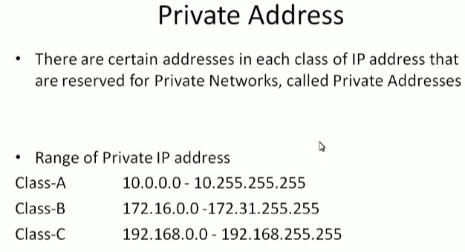

* Above are the range of private IP addresses for class A, B, C
* We can use other ips also. It is recommended to use these ips

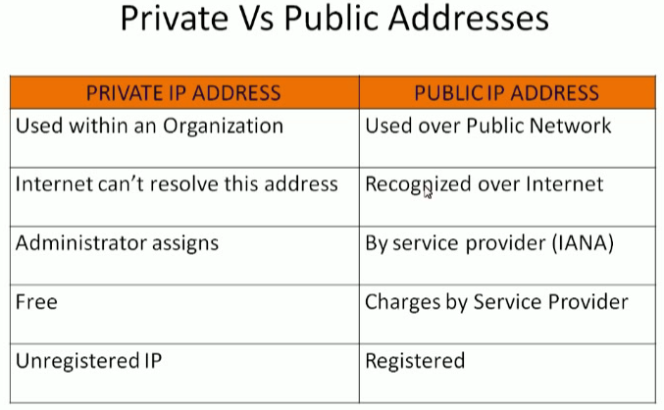

* is 9, then n=32-h=23 should be the subnet

**NAT:**

* Inside the network, we have private IP. If we have to make an outside connection, we need public IP
* Router is configured to public IP
* Whenever we are making a connection request from device with private ip, we will be first connecting to router and here the router will understand, and it will assign a public IP to us. So once the request done, whichever the public ip assigned to us will be converted to private
* This process is called Natting NAT (Network Address Translation)
* Suppose we have a subnet and wants to expose them to internet but don’t want other subnets to expose
* The subnet which we want to expose to internet is called public subnet. Remaining are private subnet
* NAT server gonna be launched in public subnet
* NAT helps to translate public to private and private to public

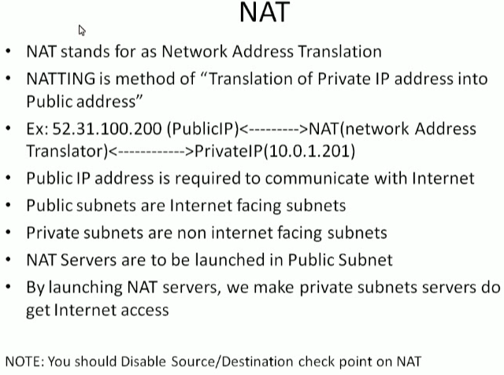

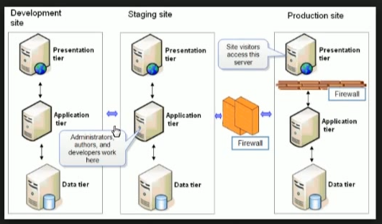

* If we have created elastic IP and associate to instance. Then there is no charge for it
* But if we haven’t associate it after creating. Then there will be charge as there are very less elastic IPs
* Subnet mask series in AWS is from /16 to /28